American Friends of The National Gallery of Denmark launches crowdfunding initiative to preserve unique Matisse painting

New York, October 5, 2021
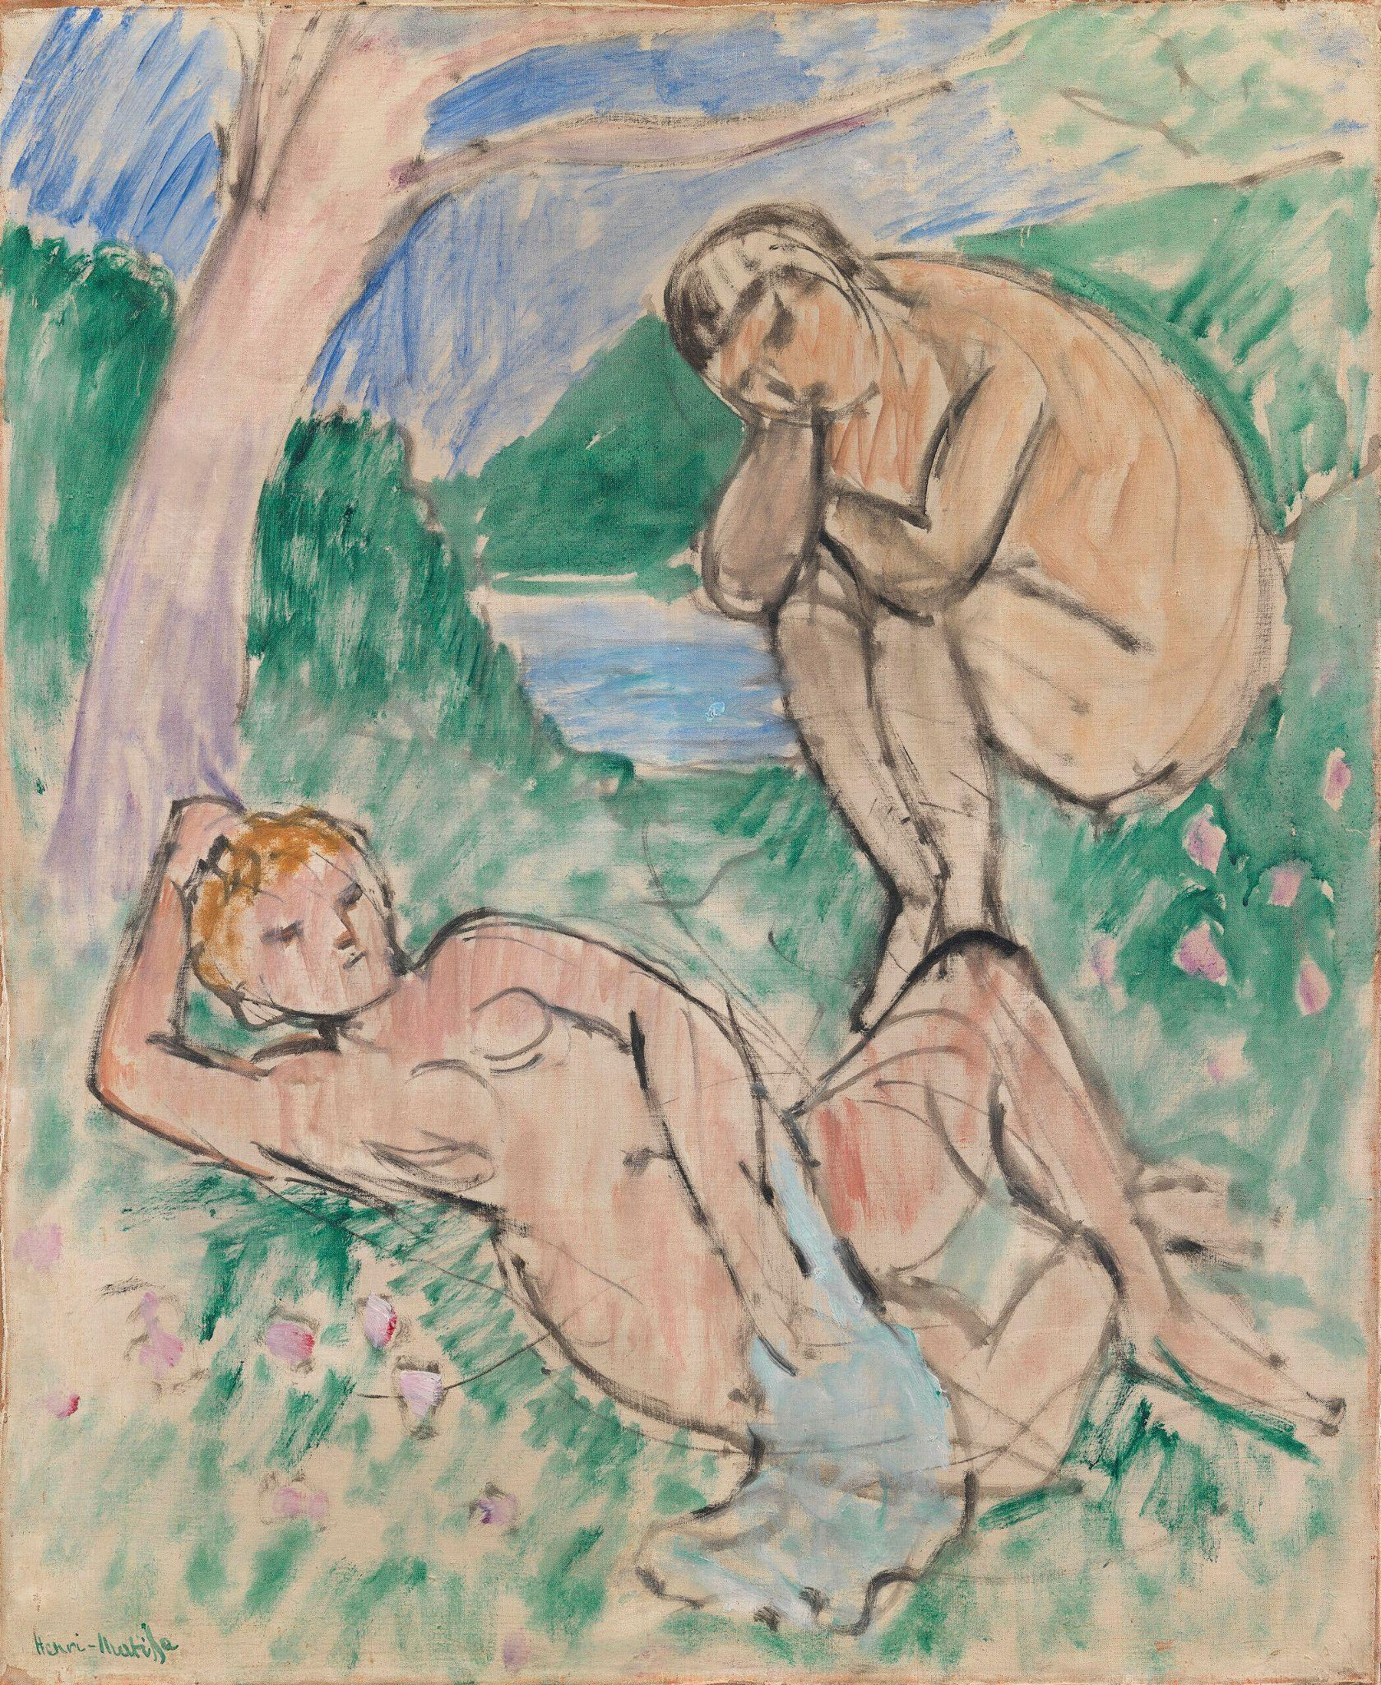
A unique painting by Henri Matisse has reappeared. After 100 years in private collections, Nymph and Faun was acquired by SMK, The National Gallery of Denmark, in 2018. The painting is to be shown to the American public for the very first time as part of a Matisse exhibition at The Museum of Modern Art in New York in May 2022 but is in need of conservation treatment. American Friends of SMK, AFSMK, therefore sends out a call for support to raise the $30,000 needed for the restoration through a crowdfunding initiative that starts on kickstarter.com today.
Henri Matisse, Nymph and Faun,
c. 1911, Oil on canvas, 73 x 59 cm,
SMK - The National Gallery of Denmark
© 2021 Succession H. Matisse / Artists Rights Society (ARS), New York

Nymph and Faun has a very special history. It was painted in 1911 and became part of a private collection in Copenhagen just after WWI. In 1927, it was sold to a German private collector after which it disappeared from public view. A few years ago, it suddenly turned up and was offered to SMK, The National Gallery of Denmark, who acquired it in 2018. After being in private hands for more than 100 years the painting is now in need of conservation treatment.

“It is not often that you have a painting of this age and importance that has not been fully treated,” Loa Ludvigsen, Paintings Conservator at SMK, explains about the condition of the painting. “In order for the painting to cross the Atlantic it would need to be stabilized and cleaned for it to travel safely. The treatment is crucial, if the painting is to go on exhibition,” she concludes.

The crowdfunding campaign to raise the $30,000 needed is listed on Kickstarter and was initiated by AFSMK, who is a key contributor in all Danish/American collaborations with The National Gallery of Denmark. “At this moment, Nymph and Faun cannot travel to the US and be part of the exhibition at MoMA without treatment,” Hanne Støvring, Executive Director of AFSMK explains about this ask for support. “Securing the funds needed for this restoration is an important part of the work of AFSMK and connected to our mission: to make the unique collections of The National Gallery of Denmark available to an American audience.”

The initiative speaks to art lovers, conservation affiliates as well as people with a general interest in supporting the international cultural scene. “We hope that they will see the importance in contributing to this restoration project,” Hanne Støvring says, "both in order to preserve a part of our common art history but also to make this unique painting available to the public outside the walls of SMK. This exhibition - first at MoMA in New York – will be a very special opportunity to see the painting in a cleaned and restored condition where it has regained its original vibrancy of color.”

Nymph and Faun is to be part of the exhibition Henri Matisse: The Red Studio at MoMA, named after another large and revolutionary painting by Matisse that shows a corner of his studio in Issy-les-Moulineaux. The forthcoming exhibition will feature Matisse’s The Red Studio, 1911 (The Museum of Modern Art, New York) and for the first time in 100 years, Nymph and Faun will be reunited with all the works in The Red Studio including two important works from SMK’s collection. This is why this painting is so essential to the exhibition. The exhibition is the result of a close collaboration between MoMA and SMK. Following its presentation at MoMA, Henri Matisse: The Red Studio will be shown at the SMK – The National Gallery of Denmark in Copenhagen from October 13, 2022, through February 26, 2023.

By backing the crowdfunding campaign, supporters also buy in to the opportunity to follow the conservation process and participate in exclusive events in both the US and Denmark. To learn more about the preservation of Nymph and Faun by Henri Matisse and the backing opportunities, please go to: https://www.kickstarter.com/projects/1826270401/help-preserve-a-unique-matisse-painting.
(Link launches on October 5 at 8AM EST.)

The attached image of Nymph and Faun can not be cropped. The artworks must be shown in their entirety with no cropping, detailing, overprinting or manipulation of any kind. The full title of the painting as well as crediting must appear when showing the work:
Henri Matisse, Nymph and Faun, c. 1911, Oil on canvas, 73 x 59 cm, SMK - National Gallery of Denmark
© 2021 Succession H. Matisse / Artists Rights Society (ARS), New York

Link for download of Nymph and Faun image: https://www.smk.dk/en/article/henri-matisse-the-red-studio-press-images/

